# Credit Card Record System – Michael Ragsdale

## “Before” Usage Screen Shot

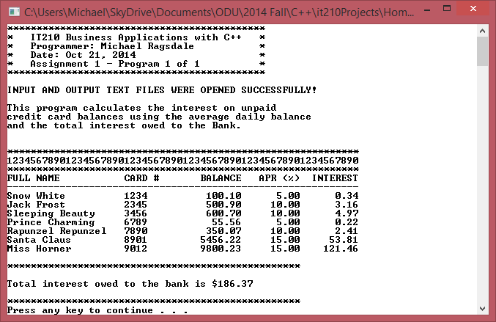

# Credit Card Record System – Michael Ragsdale

## “After” Usage Screen Shot

